ARTIGOS ORIGINAIS

CORRELAÇÃO DOS PARÂMETROS CRANIOCERVICAIS COM O ESPAÇO RETROFARÍNGEO NA ARTRODESE ATLANTOAXIAL
CORRELATION OF CRANIOCERVICAL PARAMETERS WITH RETROPHARYNGEAL SPACE IN C1-C2 POSTERIOR FUSION
CORRELACIÓN DE DOS PARÁMETROS CRANEOCERVIANOS CON EL ESPACIO RETROFARÍNGEO EN LA ARTRODESIS ATLANTOAXIAL

Luis Eduardo Carelli Teixeira da Silva¹
http://orcid.org/0000-0002-9263-4216
Alderico Girão Campos de Barros¹
http://orcid.org/0000-0002-8337-7676
Fábio Antônio Cabral de Araújo Fagundes¹
http://orcid.org/0000-0003-2900-7073
Gamaliel Gonzalez Atencio²
http://orcid.org/0000-0002-2651-7935

1. Spine Disease Center at the National Institute of Traumatology and Orthopedics (INTO), Rio de Janeiro/RJ, Brazil.
2. Orthopedics and Traumatology Service of the Chepo Regional Hospital, Chepo, Panamá
.

Local de realização do estudo.
Spine Disease Center at the National Institute of Traumatology and Orthopedics (INTO), Rio de Janeiro/RJ, Brazil.

Conflito de interesses.
Declaramos não haver conflito de interesses com a realização do estudo. Não houve qualquer fonte de financiamento que pudesse influenciar os resultados.

Correspondência
Fábio Antônio Cabral de Araújo Fagundes
Orthopedic Surgeon of the Spine Disease Center at the National Institute of Traumatology and Orthopedics (INTO).
Brasil Avenue, 500 – Caju District, Rio de Janeiro – RJ. 20940-070.
dr.fabiofagundes@gmail.com

RESUMO
INTRODUÇÃO/OBJETIVO: A junção craniovertebral (JCV) deve ter avaliação detalhada já que as alterações de alinhamento ocasionadas por uma abordagem cirúrgica podem acometer estruturas adjacentes de forma secundária. O exemplo mais evidente na literatura é a dispnéia ou disfagia após artrodese occipitocervical posterior, por diminuição no calibre da orofaringe. Estas complicações parecem que estão relacionadas com a menor distância do espaço orofaríngeo e pode ocorrer em pacientes em pós-operatório de artrodese atlantoaxial (C1-C2). Este trabalho tem o objetivo de correlacionar a variação dos parâmetros de alinhamento da JCV no pré e pós-operatório de artrodese atlantoaxial e a variação do narrowest oropharyngeal airway space (nPAS). METODOLOGIA: Pacientes submetidos a artrodese posterior C1-C2 entre 2011 e 2019 no Instituto Nacional de Traumatologia e Ortopedia (INTO) foram incluídos no estudo, totalizando 26 casos. Os parâmetros avaliados incluíram a lordose cervical, o ângulo C1-C2, o slope de C2, o ângulo occipito-c2 (O-C2), o pharyngeal inlet angle (PIA), o pharyngeal tilt angle (PTA), occiput and external acoustic meatus to axis angle (O-EAa), cranial transverse motion against c2 angle (C2TA), axial tilt (AT) e a porcentagem de mudança da narrowest oropharyngeal airway space (%∆nPAS). RESULTADO: Foi observada correlação entre a mudança do angulo C1-C2, OC2, PTA, C2TA e a %∆nPAS. CONCLUSÃO: A mudança dos parâmetros de alinhamento cervical e da junção craniovertebral tem correlação com a %∆nPAS e por isso devem ser avaliadas no pré e pós-operatório de artrodese atlantoaxial como forma de prever uma possível complicação respiratória.

ABSTRACT
INTRODUCTION / OBJECTIVE: The craniovertebral junction (CVJ) must have a detailed evaluation, since the alignment changes caused by a surgical approach can affect adjacent structures in a secondary way, such as dyspnea or dysphagia after posterior occipitocervical arthrodesis, due to a decrease in the caliber of the oropharynx. These changes can be identified in the perioperative period by several radiographic parameters that try to predict a possible postoperative respiratory complication. This complication seems to be related to the narrowest oropharyngeal airway space (nPAS) and can also occur in patients in the postoperative period of atlantoaxial (C1-C2) arthrodesis. This work aims to correlate the variation of the alignment parameters of the CVJ in the pre and postoperative of C1-C2 arthrodesis and the variation of nPAS. METHODS: Patients who underwent posterior C1-C2 arthrodesis between 2011 and 2019 at the National Institute of Traumatology and Orthopedics (INTO) were included in the study, totaling 26 patients. The parameters evaluated included cervical lordosis, C1-C2 angle, slope of C2, occipito-c2 angle (O-C2), pharyngeal inlet angle (PIA), pharyngeal tilt angle (PTA), occiput and external acoustic meatus to axis angle (O-EAa), cranial transverse motion against c2 angle (C2TA), axial tilt (AT) and the percentage of change in nPAS (%∆nPAS). RESULT: Correlation was observed between the change in angle C1-C2, O-C2, PTA, C2TA and the %∆nPAS. CONCLUSION: The change in cervical alignment and CVJ parameters has a correlation with %∆nPAS and therefore should be evaluated before and after atlantoaxial fusion as a way of predicting a possible respiratory complication. Level of evidence: III; Cross sectional study.
Keywords: Dyspnea; Deglutition Disorders; Atlanto-Axial Fusion;.

RESÚMEN
INTRODUCCIÓN/OBJETIVO: La unión craneovertebral es una región compleja y, por tanto, debe ser objeto de una evaluación detallada, ya que los cambios de alineación provocados por un abordaje quirúrgico pueden afectar de forma secundaria a las estructuras adyacentes. El ejemplo más evidente en la literatura es la disnea o disfagia tras una artrodesis occipitocervical posterior, por disminución del calibre de la orofaringe. Este cambio puede identificarse en el período perioperatorio por varios parámetros radiográficos que intentan predecir una posible complicación respiratoria postoperatoria. Esta complicación parece estar relacionada con la menor distancia del espacio orofaríngeo y también puede ocurrir en pacientes en el postoperatorio de artrodesis atlantoaxial (C1-C2), ya sea por la técnica de Gallie, Magerl o Goel / Harms. Este trabajo tiene como objetivo correlacionar la variación de los parámetros de alineación de la unión craneovertebral en el pre y posoperatorio de artrodesis atlantoaxial y la variación de nPAS. METODOLOGÍA: Se incluyeron en el estudio pacientes que se sometieron a artrodesis posterior C1-C2 entre 2011 y 2019 en el Instituto Nacional de Traumatología y Ortopedia (INTO), totalizando 40 casos. Fueron excluidos aquellos cuyas radiografías no permitían tomar las medidas propuestas o tenían otros niveles incluidos en la artrodesis, totalizando 26 pacientes. Los parámetros evaluados incluyeron lordosis cervical, ángulo C1-C2, pendiente de C2, ángulo occipito-c2 (O-C2), ángulo de entrada faríngea (PIA), ángulo de inclinación faríngea (PTA), occipito y acústica externa. meato al ángulo del eje (O-EAa), movimiento transversal craneal contra el ángulo c2 (C2TA), inclinación axial (AT) y porcentaje de cambio en nPAS (%∆nPAS). RESULTADO: Se observó correlación entre el cambio de ángulo C1-C2, O-C2, PTA, C2TA y el porcentaje de cambio en nPAS (p <0.05). CONCLUSIÓN: El cambio en los parámetros de alineación cervical y unión craneovertebral tiene una correlación con pnPAS y por lo tanto debe evaluarse antes y después de la artrodesis atlantoaxial como una forma de predecir una posible complicación respiratoria.

INTRODUCTION
The craniovertebral junction is a complex region that involves the occiput, the atlas, the axis and its capsuloligamentous components. These bones are closely related to important cervical structures, such as the vertebral artery and the oropharynx, which must be evaluated during surgical planning. This evaluation should include the possibility of direct or indirect influence, since changes in alignment caused by a surgical approach to the upper cervical spine may affect these adjacent structures in a secondary manner.¹⁻³
In the literature, one of the most prevalent complications is dysphagia after posterior occipitocervical arthrodesis, due to a decrease in the oropharynx caliber, which can affect 15.8% to 26.3% of the patients who underwent surgery.⁴ The hypothesis for this type of occurrence is that the fixation of the craniovertebral junction in a less lordotic position than the preoperative one causes a rotation of the maxilla with consequent posterior displacement of the mandible implying stenosis of the oropharynx. In addition, head position influences the tonic reflexes of the neck and muscle length, which change the activity of the genioglossus muscle, and patients in a more kyphotic position may also suffer suprahyoid muscle contractures, causing swallowing impairment.⁵ These changes can be identified in the perioperative period by several radiographic parameters that try to predict a possible obstructive complication in the postoperative period, based on their relationship with the narrowest oropharyngeal airway space (nPAS) – anteroposterior distance of the oropharyngeal region in its narrowest portion seen on the lateral radiograph of the cervical spine, between the uvula and the epiglottis, which has a good correlation with the swallowing function. The variation of the of occipito-C2 angle (OC2) is the most mentioned parameter and has a linear correlation with the percentage change of the narrowest oropharyngeal airway space (%ΔnPAS).¹⁻³
Another morbidity associated with this procedure is the restriction of the patient’s craniocervical flexion-extension, hindering his/her daily activities. By evaluating this, Goel et al. proposed that instability of the craniocervical junction is usually concentrated in the atlantoaxial joint and, therefore, only atlantoaxial arthrodesis would be sufficient for effective treatment.⁶ Nevertheless, it should be remembered that this instability is strongly associated with atlas assimilation, since this vertebra has the same embryological origin as the atlantoaxial ligaments,⁷ thus directly altering the occipitocervical alignment and restricting the flexion-extension of this region, even not including the occiput (C0) in case of treatment with the Goel/Harms technique.⁸ It is known that this technique is also associated with postoperative dysphagia; however, there are still no studies that evaluate this complication in these cases.
Given the above, this study has the objective of correlating the changes in the alignment parameters of the cervical spine and craniovertebral junction in the pre and postoperative period of atlantoaxial fusion through the Goel/Harms technique with the percentage variation of nPAS.

METHODOLOGY
Patients who underwent posterior C1-C2 arthrodesis between 2011 and 2019 at the National Institute of Traumatology and Orthopedics (INTO) were included in the study, totaling 40 cases. Those whose radiographs did not allow the proposed measurements to be taken or had other levels included in the arthrodesis were excluded. Therefore, a total of 26 patients were included in the study and their medical records were retrospectively analyzed. This study was approval by the INTO ethics committee (CAAE: 21225019.0.0000.5273). As for the radiographic analyses, they were performed through the Surgimap® software.
Statistical analysis was performed using the R® software, version 4.0.2. A multiple linear regression was performed by correlating the variation of radiographic parameters and the percentage variation of nPAS.
Radiographic Parameters
The variation of the following pre and postoperative parameters was evaluated: C1-C2 angle, C2-C7 angle, C2 slope (CS), occipito-C2 angle (OC2), pharyngeal inlet angle (PIA), pharyngeal tilt angle (PTA), occiput and external acoustic meatus to axis angle (OEA), cranial transverse motion against c2 angle (C2TA), axial tilt (AT) and the percentage change of the narrowest oropharyngeal airway space (%ΔnPAS). Some parameters used Mcgregor line⁹ and Chamberlain line¹⁰ for measurement. Mcgregor line is drawn from the hard palate to the most caudal point of the occipital bone, and Chamberlain line is drawn from the hard palate to the posterior margin of the foramen magnum, both on lateral radiographs of the cervical spine.
The C1-C2 angle comprises that between a line tangent inferiorly to the arc of C1 and a line tangent to the inferior endplate of C2. The measurement of the C2-C7 angle (cervical lordosis) was performed using the modified Cobb method, starting with the identification of the inferior endplate of C2 and C7, thus drawing a line tangent to these references. Subsequently, a line perpendicular to each of them is drawn, and the acute angle formed between them is the C2-C7 angle. The C2 slope is measured by the angle formed between a line tangent to the inferior endplate of C2 and a horizontal reference line. The pharyngeal inlet angle was measured between Mcgregor line and the line joining the center of the anterior arch of C1 and the apex of the cervical lordosis. In turn, the pharyngeal tilt angle was measured between Mcgregor line and a line that goes from the C2 pedicle to the center of the body of the vertebra to the apex of the cervical lordosis (FIGURE 1A).
The occipito-C2 angle was measured between the Mcgregor line, which is more easily identified on radiographs, and a line tangent to the inferior endplate of C2. In turn, the occiput and external acoustic meatus to axis angle was measured between Mcgregor line and the line that goes from the center of the external acoustic meatus (or the center of a line that joins the two meatus) to the midpoint of the inferior endplate of C2. The cranial transverse motion against c2 angle was obtained between the line that goes from the center of the external acoustic meatus (or from the center of a line that joins the two meatus) to the midpoint of the inferior endplate of C2 and the line tangent to the inferior endplate of C2. The axial tilt was measured between the Chamberlain line and a tangent line posteriorly to the C2 body and the odontoid process (FIGURE 1B).
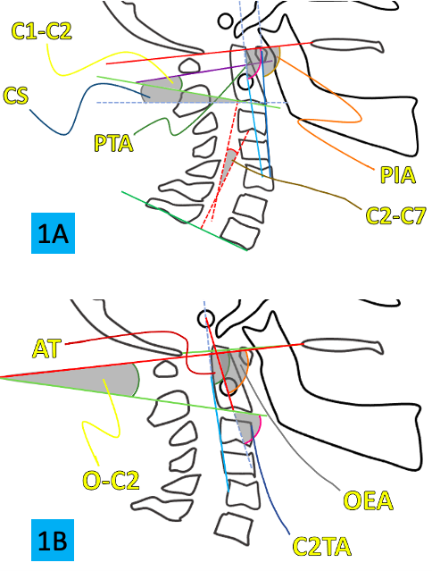
Figure 1. Radiographic Parameters: A – C1-C2: C1-C2 angle; C2-C7: Cervical Lordosis; CS: C2 slope; PIA: Pharyngeal inlet angle; PTA: Pharyngeal tilt angle/ B – OC2: occipito-C2 angle; OEA: occiput and external acoustic meatus to axis angle; C2TA: cranial transverse motion against c2; AT: axial tilt.

The narrowest oropharyngeal airway space (nPAS) was obtained by transversely measuring the hypopharynx in its narrowest portion between the uvula and the epiglottis (FIGURE 2). As the percentage change of the narrowest oropharyngeal airway space, it was obtained by means of the following formula:
%ΔnPAS = (postoperative nPAS – preoperative nPAS) / preoperative nPAS x 100.
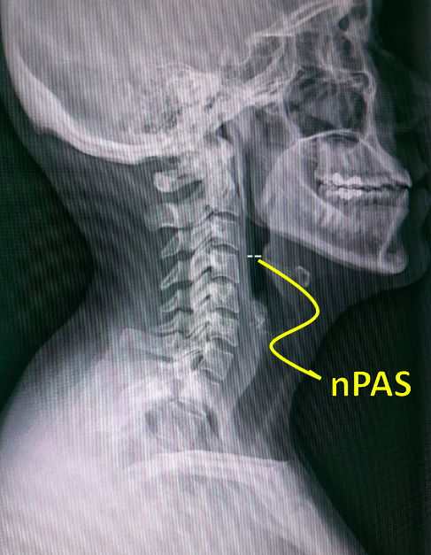
Figure 2. Measurement of the narrowest oropharyngeal airway space (nPAS) on lateral radiography of the cervical spine

RESULTS
After applying the inclusion and exclusion criteria, 26 patients were selected for analysis, with an average age of 40.34 years, with the diagnosis of basilar invagination being the most common among these individuals.
The general clinical-surgical features of the patients are summarized in Table 1.

Table 1. General clinical-surgical features.
Feature | Absolute number | Percentage
Gender  Male  Female | 14  12 | 54%  46%
Diagnosis  Basilar invagination Grisel syndrome  Odontoid fracture  Type 1 Chiari malformation  C1-C2 spondylodiscitis  Atlas fracture | 18  3  2  1  1  1 | 69%  11%  8%  4%  4%  4%
ASIA classification  E  D  C  B  A | 14  9  3  0  0 | 54%  35%  11%  0%  0%
Type of Surgery  Isolated C1-C2 fusion  Distraction + C1-C2 fusion | 8  18 | 31%  69%
ASIA - American Spinal Injury Association; Isolated C1-C2 fusion – Harms technique; Distraction + C1-C2 fusion – Goel technique.
The investigation of associated factors was carried out using multiple linear regression variables.

Only the variation of C1-C2, OC2, PTA and C2TA showed a statistically significant correlation with %ΔnPAS (Table 2).

Regression analysis of %ΔnPAS with radiographic variables
Regressive variables | Non-standardized coefficient |  | t | p-value | VIF
 | B | Standard error
Constant | -0.75 | 0.25 | -3.02 | 0.017
ΔC1-C2 | 0.01 | 0.01 | 2.49 | 0.037 | 6.86
ΔC2-C7 | 0.00 | 0.00 | -1.11 | 0.301 | 4.98
ΔCS | 0.01 | 0.00 | 1.44 | 0.188 | 4.43
ΔOC2 | 0.05 | 0.02 | 2.40 | 0.043 | 66.54
ΔPIA | 0.01 | 0.01 | 0.92 | 0.385 | 17.40
ΔPTA | 0.03 | 0.01 | 4.43 | 0.002 | 6.70
ΔOEA | -0.03 | 0.02 | -1.85 | 0.102 | 36.42
ΔC2TA | 0.03 | 0.01 | 2.49 | 0.037 | 25.84
ΔAT | -0.02 | 0.01 | -1.78 | 0.112 | 23.74
Table 2. Result of regression analysis.

ΔC1-C2: C1-C2 angle variation; ΔC2-C7: Cervical Lordosis variation; ΔCS: C2 slope variation; ΔOC2: occipito-C2 angle variation; ΔPIA: Pharyngeal inlet angle variation; ΔPTA: Pharyngeal tilt angle variation; ΔOEA: occiput and external acoustic meatus to axis angle variation; ΔC2TA: cranial transverse motion against c2 variation; ΔAT: axial tilt variation.

Through the chart below (FIGURE 3), it is possible to observe that the Gauss-Markov condition is being met, as no apparent pattern is occurring, i.e., the variance is constant, and the behavior of the residuals is around the average equal to 0.

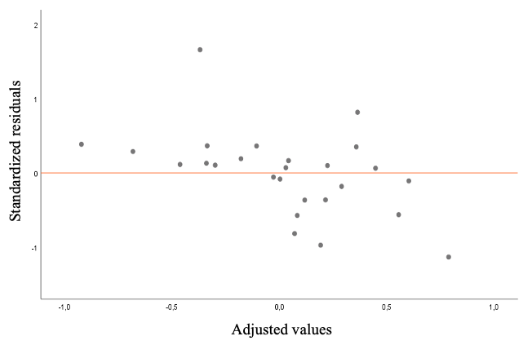
Figure 3. Scatter plot of standardized residuals versus adjusted values.

Through graphical analysis (FIGURE 4) and through the Shapiro-Wilk test (Value - p = 0.090), attributing a significance level of 5%, it is possible to obtain statistical evidence that the residuals have a normal distribution.
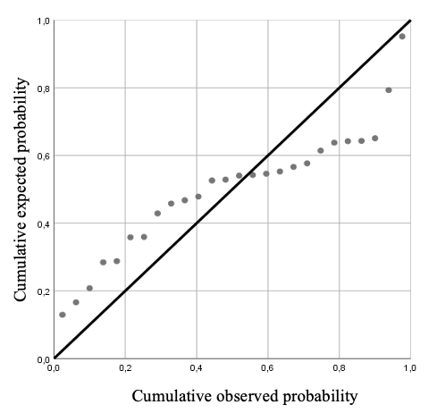
Figure 4, Normal probability distribution.

DISCUSSION
Classically, surgical stabilization of the craniovertebral junction is performed with posterior occipitocervical fusion. This method has some inherent morbidities, including the loss of 50% of craniocervical flexion and 50% of cervical rotation. In addition, dysphagia and dyspnea should be mentioned, because of secondary decrease in the oropharynx caliber, either due to edema or changes in the cervical or craniovertebral alignment, which can entail a devastating outcome.¹¹
Maintaining mobility is one of the advantages of preserving the occiput by performing only atlantoaxial fusion surgery, even facilitating swallowing by maintaining the C0-C1 dynamic compensation mechanism. However, even not including the occiput by performing arthrodesis only of C1-C2 by the Goel/Harms method, obstructive symptoms can still be noticed, which can cause decrease in the patient’s quality of life, such as alterations in positioning and the need to use a continuous positive airway pressure device to sleep, as well as a change in the consistency of food to improve swallowing.^{11,12} Nevertheless, it should be remembered that atlantoaxial instability is strongly associated with atlas assimilation, since this vertebra has the same embryological origin as the atlantoaxial ligaments,⁷ thus causing the same implications of an occipitocervical instrumentation, even not including C0, a fact observed in 69% of our sample.
To avoid this, one must use parameters that evaluate the diameter of the oropharynx after the final positioning of the arthrodesis. Direct evaluation would be ideal; but, in the intraoperative period, it is technically very difficult due to the interposition of structures around the pharynx. Accordingly, one must use parameters that correlate with %ΔnPAS to predict the oropharyngeal space at the end of the procedure.
Several parameters have already been described in the literature for this purpose. The most cited is the OC2 angle.^{3,5,13} Decreases in this angle of 5 to 10° in relation to the preoperative period can lead to obstructive complications.^{14,15} In our sample, this angle had a good statistical correlation (p = 0.043) with %ΔnPAS. However, it should be remembered that this can be modified by changes in the C2 endplate,¹⁶ congenital or acquired, and some studies did not show a good correlation with %ΔnPAS,^{17,18} such as those that evaluated the treatment of atlantoaxial dislocation. Another factor that can reduce the nPAS index is the reduction in C1-C2 dislocation because it entails posterior translation of the skull, despite the increase in the OC2 angle.⁵ This translation can be measured by OEA and C2TA, which use the external auditory meatus as a reference. These seem to correlate well with %ΔnPAS,^{4,19} and are easier to measure compared to the OC2 angle. In our study, only C2TA was shown to have a statistically significant correlation (p = 0.037) with %ΔnPAS after multiple linear regression analysis. The OEA also has the advantage of not being influenced by morphological changes in the C2 endplate, since it does not involve this in the measurement. However, it is known that the external auditory meatus is also a difficult parameter to be identified on lateral radiographs of the cervical spine.²⁰
In addition to the edema and mandibular movements caused by an increase in craniovertebral kyphosis, the reciprocal changes of the subaxial cervical spine also seems to be involved in the genesis of the oropharyngeal narrowing, since the reciprocal increase in the cervical lordosis can cause a compressive effect anteriorly on the hypopharynx (FIGURE 5). Based on this, some parameters were described relating the alignment of the subaxial cervical spine to obstructive symptoms, such as PIA and PTA.^{17,18} The PTA must be equal to or greater than 77° to avoid obstructive complications, whereas the PIA must be equal to or greater than 90°.²¹ In our case, only PTA had a statistically significant correlation (p=0.002) with %ΔnPAS. Despite all this warning level, one must always remember that, if fixation of the craniocervical junction in a more kyphotic position can lead to complications, fixation in hyperextension can also lead to kyphosis and degenerative disease of the subaxial cervical spine in the long term.²²

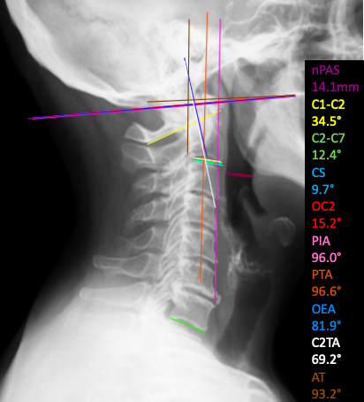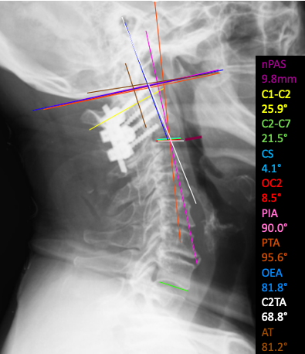
B
A
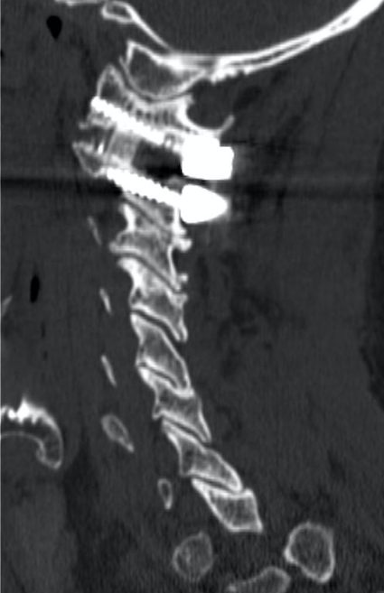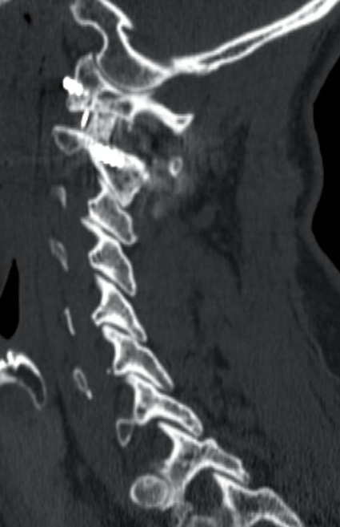
C
Figure 5. A - Female patient, with basilar invagination, with preoperative measurements. B - Postoperative measurements after treatment with the C1-C2 distraction arthrodesis technique, a decrease in craniocervical lordosis parameters (C1-C2, OC2, PTA and C2TA) and a reciprocal increase in subaxial cervical lordosis with consequent decrease in nPAS. C – Posoperative Computed Tomography in sagittal reconstruction showing distraction in C1-C2 joint with cages.

This study has some limitations. It is known that breathing and swallowing involve a dynamic process and, therefore, are difficult to be evaluated by static measurements such as nPAS. Many factors, including organic and functional disorders, can cause dyspnea and/or dysphagia. Measurements were performed using standard software, but it is known that these measurements have a large inter and intra-observer variability due to the difficulty of measuring the parameters of each of these angles. Another way of measuring described in the literature is intraoperative computed tomography, to always try to keep the craniocervical junction in a neutral or more extended position in relation to the preoperative period. This prevents atlantoaxial fixation from occurring in a cervical retraction position (˜military tuck˜), which is sometimes used to facilitate surgical access and C1-C2 reduction, thus avoiding obstructive complications.²³ In our sample, only 5 patients evolved with dysphagia and 2 patients with dyspnea in the postoperative period, probably due to its small sample. Thus, a prospective study with a larger number of patients is needed to confirm the correlations described here, including their clinical manifestations.

CONCLUSION
The changes in C1-C2, OC2, PTA and C2TA showed a statistical correlation with %ΔnPAS in atlantoaxial fusion surgeries and, therefore, should be evaluated during surgery to predict a possible obstructive complication.

CONTRIBUIÇÃO DOS AUTORES
Substantial contribution to the concept or design of the work, or the acquisition, analysis, or interpretation of data for the work
Luis Eduardo Carelli Teixeira da Silva
Alderico Girão Campos de Barros
Fábio Antônio Cabral de Araújo Fagundes
Gamaliel Gonzalez Atencio

Writing of the work or critical review of its intellectual content
Luis Eduardo Carelli Teixeira da Silva
Alderico Girão Campos de Barros
Fábio Antônio Cabral de Araújo Fagundes

Approval of the final version of the manuscript to be published
Luis Eduardo Carelli Teixeira da Silva
Alderico Girão Campos de Barros
Fábio Antônio Cabral de Araújo Fagundes

REFERENCES
- Izeki M, Neo M, Takemoto M, Fujibayashi S, Ito H, Nagai K, et al. The O-C2 angle established at occipito-cervical fusion dictates the patient's destiny in terms of postoperative dyspnea and/or dysphagia. Eur Spine J. 2014;23(2):328-36.
- Guan J, Jian F, Yao Q, Yuan C, Zhang C, Ma L, Liu Z, Duan W, Wang X, Bo X, Chen Z. Quantitative Reduction of Basilar Invagination With Atlantoaxial Dislocation by a Posterior Approach. Neurospine. 2020 Sep;17(3):574-584.
- Yoshida M, Neo M, Fujibayashi S, Nakamura T. Upper-airway obstruction after short posterior occipitocervical fusion in a flexed position. Spine. 2007;32(8):E267-70.
- Chen T, Yang X, Kong W, Li Z, Song Y. Impact of the occiput and external acoustic meatus to axis angle on dysphagia in patients suffering from anterior atlantoaxial subluxation after occipitocervical fusion. Spine J. 2019;19(8):1362-8.
- Izeki M, Neo M, Ito H, Nagai K, Ishizaki T, Okamoto T, et al. Reduction of atlantoaxial subluxation causes airway stenosis. Spine (Phila Pa 1976). 2013;38(9):E513-20.
- Goel A. Occipitocervical fixation: Is it necessary? J Neurosurg Spine. 2010;13(1):1-2.
- Menezes AH. Primary craniovertebral anomalies and the hindbrain herniation syndrome (Chiari I): data base analysis. Pediatr Neurosurg 1995;23(5):260-9.
- Harms J, Melcher RP. Posterior C1-C2 fusion with polyaxial screw and rod fixation. Spine. 2001;26(22):2467-71.
- McGregor M. The significance of certain measurements of the skull in the diagnosis of basilar impression. Br J Radiol. 1948;21(244):171-81.
- Chamberlain WE. Basilar Impression (Platybasia): A Bizarre Developmental Anomaly of the Occipital Bone and Upper Cervical Spine with Striking and Misleading Neurologic Manifestations. Yale J Biol Med. 1939;11(5):487-96.
- Gonda DD, Huang M, Briceño V, Lam SK, Luerssen TG, Jea A. Protecting Against Postoperative Dyspnea and Dysphagia After Occipitocervical Fusion. Oper Neurosurg (Hagerstown). 2020;18(3):254-60.
- Kim JY, Hong JT, Oh JS, Jain A, Kim IS, Lim SH, et al. Influence of neck postural changes on cervical spine motion and angle during swallowing. Medicine (Baltimore). 2017;96(45):e8566.
- Ota M, Neo M, Aoyama T, Ishizaki T, Fujibayashi S, Takemoto M, et al. Impact of the O-C2 angle on the oropharyngeal space in normal patients. Spine (Phila Pa 1976) 2011;36(11):E720-6.
- Meng Y, Wu T, Liu Z, Wen D, Rong X, Chen H, et al. The impact of the difference in O-C2 angle in the development of dysphagia after occipitocervical fusion: a simulation study in normal volunteers combined with a case-control study. Spine J. 2018;18(8):1388-97.
- Miyata M, Neo M, Fujibayashi S, Ito H, Takemoto M, Nakamura T. O-C2 angle as a predictor of dyspnea and/or dysphagia after occipitocervical fusion. Spine (Phila Pa 1976). 2009;34(2):184-8.
- Harrison DE, Harrison DD, Cailliet R, Troyanovich SJ, Janik TJ, Holland B. Cobb method or Harrison posterior tangent method: which to choose for lateral cervical radiographic analysis. Spine (Phila Pa 1976). 2000;25(16):2072-8.
- Kaneyama S, Sumi M, Takabatake M, Kasahara K, Kanemura A, Koh A, et al. Preliminary Evaluation of the Pathomechanisms of Dysphagia After Occipitospinal Fusion: Kinematic Analysis by Videofluoroscopic Swallowing Study. Spine (Phila Pa 1976). 2016;41(23):1777-84.
- Kaneyama S, Sumi M, Kasahara K, Kanemura A, Takabatake M, Yano T. Dysphagia After Occipitothoracic Fusion is Caused by Direct Compression of Oropharyngeal Space Due to Anterior Protrusion of Mid-cervical Spine. Clin Spine Surg. 2017;30(7):314-20.
- Morizane K, Takemoto M, Neo M, Fujibayashi S, Otsuki B, Kawata T, et al. Occipital and external acoustic meatus to axis angle as a predictor of the oropharyngeal space in healthy volunteers: a novel parameter for craniocervical junction alignment. Spine J. 2018;18(5):811-17.
- Wang LN, Hu BW, Song YM, Liu LM, Zhou CG, Wang L, et al. Predictive abilities of O-C2a and O-EAa for the development of postoperative dysphagia in patients undergoing occipitocervical fusion. Spine J. 2020;20(5):745-53.
- Wang LN, Hu BW, Song YM, Liu LM, Zhou CG, Wang L, et al. Predictive ability of pharyngeal inlet angle for the occurrence of postoperative dysphagia after occipitocervical fusion. BMC Musculoskelet Disord. 2021;22(1):54.
- Yoshida G, Kamiya M, Yoshihara H, Kanemura T, Kato F, Yukawa Y, et al. Subaxial sagittal alignment and adjacent-segment degeneration after atlantoaxial fixation performed using C-1 lateral mass and C-2 pedicle screws or transarticular screws. J Neurosurg Spine. 2010;13:443-50.
- Huang M, Gonda DD, Briceño V, Lam SK, Luerssen TG, Jea A. Dyspnea and dysphagia from upper airway obstruction after occipitocervical fusion in the pediatric age group. Neurosurg Focus. 2015;38(4):E13.

